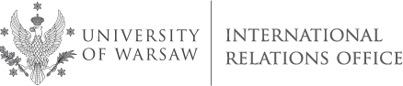

University of Warsaw (PL WARSZAW01)
9th International Staff Training Week
4 - 8 June, 2018
Central Campus: Krakowskie Przedmieście 26/28, Warsaw

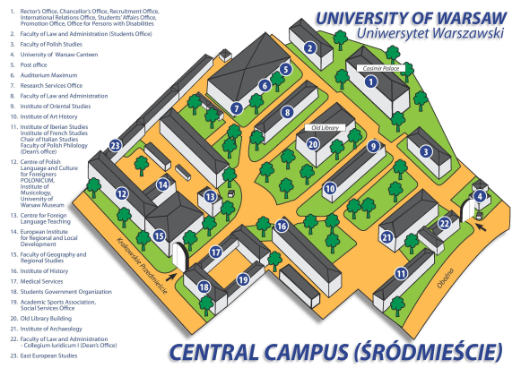

CROSS-CULTURAL COMMUNICATION.
RESOLVING CONFLICTS IN AN INTERCULTURAL COMMUNITY

PROGRAMME

Monday, 4 June, venue: Brudziński Hall, Casimir Palace, ground floor, right side

12.00 – 12.30 | Registration and welcome coffee
13.00 - 13.30 | Opening session: welcome address, introduction to the University of Warsaw, IRO at a glance
13.30 – 14.30 | Who is who: presentation of participants
14.45 – 17.00 | Campus tour and walk around the Old Town
17.00 – 20.00 | Welcome dinner, Zapiecek Restaurant: We invite you to participate in a unique “workshop” on  making Polish traditional dumplings (pierogi).
Tuesday, 5 June, venue: to be confirmed

9.00 – 10.30 | Resolving conflicts in an intercultural community – workshop, part 1:  - Conflict – definition, sources and process  - Cultural differences and communication  Trainers: Prof. Ewa Gmurzyńska, Dr. Aleksandra Winiarska
10.30 – 10.45 | Coffee/tea break
10.45 – 12.15 | Workshop - continued
12.15 – 13.00 | Lunch
13.00 – 14.30 | Workshop – continued
14.30 – 14.45 | Coffee/tea break
14.45 – 16.15 | Workshop - continued
Wednesday, 6 June, venue: to be confirmed

9.00 – 11.00 | Workshop, part 2:  - Misunderstandings and conflicts in a multicultural setting  - Possible strategies and resolutions  Trainers: Prof. Ewa Gmurzyńska, Dr. Aleksandra Winiarska
11.00 – 11.15 | Coffee break
11.15 – 13.15 | Workshop - continued
13.15 – 14.00 | Lunch
14.00 – 16.00 | Workshop - continued

Thursday, 7 June, venue: to be confirmed

9.30–12.00 | Workshop, part 3: Case Studies
12.00 Closing session: delivering certificates, evaluation of the Staff Training Week
13.00 Farewell lunch

Friday, 8 June

Individual meetings at departments

