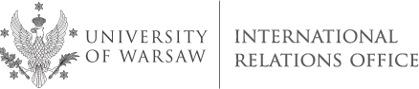

University of Warsaw (PL WARSZAW01)
International Staff Training Week
4 - 8 June, 2018

The International Relations Office of the University of Warsaw
takes the pleasure in inviting you to the 9th International Staff Training Week organized under the theme of:
CROSS-CULTURAL COMMUNICATION. RESOLVING CONFLICTS IN A MULTICULTURAL COMMUNITY

For those who want to:
- take part in a series of workshops on communication in international environment
- work on the ways of coping with problematic intercultural situations
- share ideas from different interdisciplinary perspectives on communication across cultures in international University
- analyze intercultural competence necessary in international University
- get familiar with some aspects of Polish culture, traditions and customs
- visit the University of Warsaw
Target group: administrative staff members from partner universities, particularly those who work in multicultural environment

Number of participants: 22 (max. 4 persons per country in order to ensure a mixed, international setting)

Working language: English (a good communication level is required - at least B2)
Fee: the training is free of charge. Costs of travel, insurance, accommodation and subsistence are to be covered by the participants. They can apply for Erasmus+ Staff Training Grant at their home institutions.

Accommodation & Travelling: hotel and travel information will be sent to all selected participants.

Enclosed please find draft program (can be subject to changes) and application form.

Application deadline: 6 April, 2018

Joanna Nagłowska (joanna.naglowska@adm.uw.edu.pl)
Jakub Rejniak (jakub.rejniak@adm.uw.edu.pl)
International Officers

